1

<https://www.amazon.co.uk/ANCIRS-Stainless-Electronic-Components-Accessory/dp/B08FHXDBLG/ref=asc_df_B08FHXDBLG/?tag=googshopuk-21&linkCode=df0&hvadid=483313890232&hvpos=&hvnetw=g&hvrand=16789409570303440265&hvpone=&hvptwo=&hvqmt=&hvdev=c&hvdvcmdl=&hvlocint=&hvlocphy=9045622&hvtargid=pla-974859018864&th=1>

Prongs to detect resistance of resistors while on the arm. Pulling motion to open and close gripper.

2

<https://uk.rs-online.com/web/p/power-motor-robotics-development-tools/1743254?cm_mmc=UK-PLA-DS3A-_-google-_-CSS_UK_EN_Raspberry_Pi_%26_Arduino_%26_Development_Tools_Whoop-_-Power+%26+Motor+%26+Robotics+Development+Tools_Whoop_OMNISerpNov-_-1743254&matchtype=&aud-827186183886:pla-340279859205&cq_src=google_ads&cq_cmp=10914490524&cq_term=&cq_plac=&cq_net=g&cq_plt=gp&gclid=CjwKCAjwh4ObBhAzEiwAHzZYUz5lv6Wm4qKGHAPMHbkaYYYkSo66DWcywWRisIT2mZjQBost2RbgRhoCIiYQAvD_BwE&gclsrc=aw.ds>

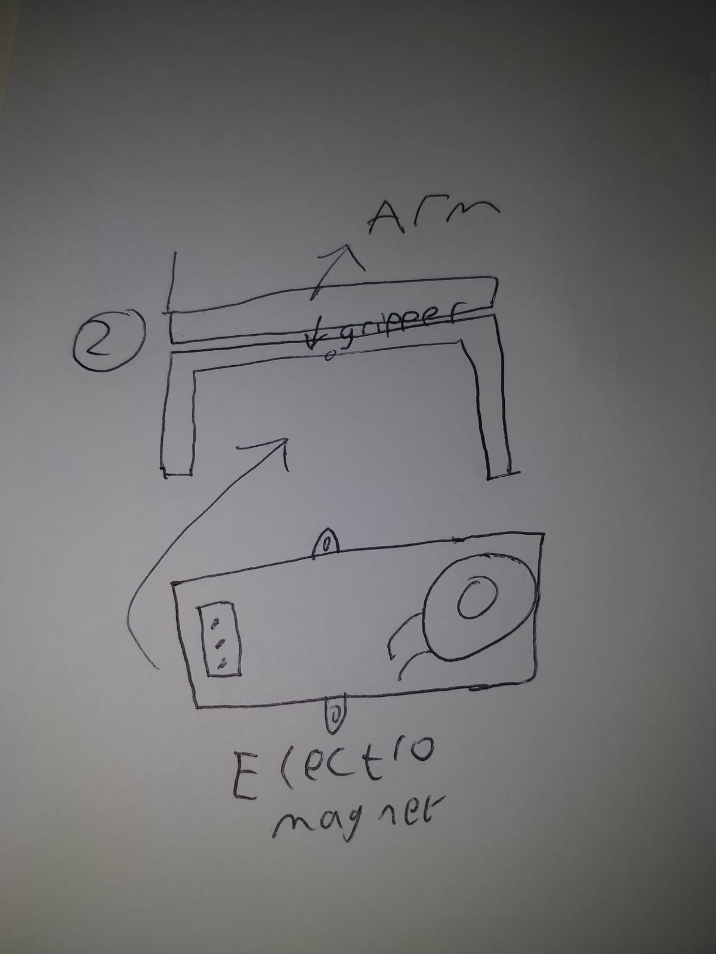Electromagnet gripper. Mount Module on the gripper part of the arm.

